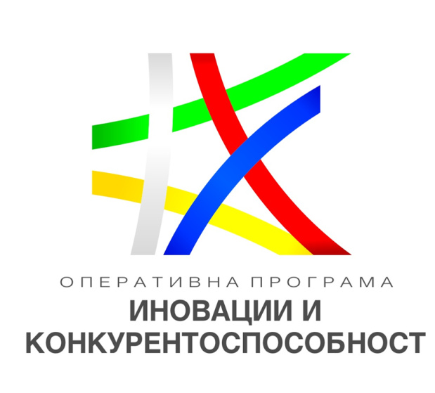

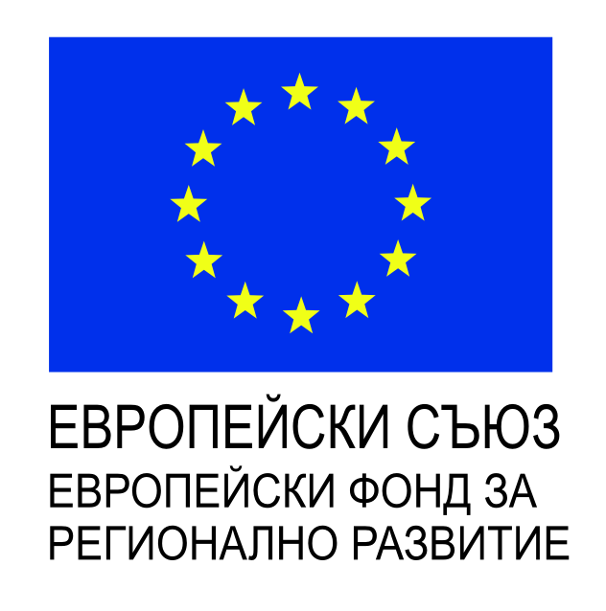

**Procedure:** BG16RFOP002-2.073 “Support to micro and small enterprises to overcome the economic consequences of the COVID-19 pandemic” under OP “Innovation and Competitiveness 2014-2020”, co-financed by the European Union through the European Regional Development Found and the national budget of the Republic of Bulgaria

**Project and main objective**: Overcoming the shortage of funding and the lack of liquidity caused by the epidemic outbreak of COVID-19  
   
**Contract number:** BG16RFOP002-2.073-14251-C01

**Beneficiary:** VANCOM - LTD  
   
**Total value:** BGN10,000, of which BGN 8,500 European and BGN 1.500 national co-financing  
   
**Start:** 17.09.2020  
**End:** 17.12.2020